A CASE-STUDY BASED REPORT
ON
MACHINE LEARNING BASED HEART DISEASE RISK PREDICTION
USING CLINICAL PATIENT PARAMETERS
submitted in partial fulfilment of the requirements for the course
MACHINE LEARNING
BACHELOR OF TECHNOLOGY
A.Y. 2026–27

Submitted by
Vineetha | 2520030149
Mahitha | 2520030469

Under the guidance of
Dr. G S Raghavendra
Assistant Professor, Department of CS&IT
Koneru Lakshmaiah Education Foundation (KL University)
Hyderabad, Telangana

CONTENTS
Abstract
1. Introduction
2. Problem Statement and Objectives
3. Project Overview and System Architecture
4. Dataset and Data Audit
5. Exploratory Data Analysis
6. Data Preprocessing and Feature Engineering
7. Model Development and Validation
8. Results and Discussion
9. Application Features and Deployment
10. Limitations and Responsible Use
11. Conclusion and Future Work
References
Note: Page numbers can be refreshed automatically in Word if an automatic table of contents is inserted.

Abstract
This report documents the Heart Disease Prediction System contained in the supplied project ZIP. The application uses Python and machine-learning tools to estimate the likelihood of heart disease from 13 routinely recorded clinical attributes. It includes data-quality auditing, exploratory data analysis, preprocessing pipelines, comparison of eight classifiers, nested cross-validation, held-out test evaluation, prediction explanations, patient segmentation, a Streamlit interface, a command-line predictor, and a FastAPI endpoint.
The supplied Cleveland heart-disease CSV contains 303 records and 14 columns. The audit found one duplicate row and out-of-range category codes that represent hidden missing values in the exported dataset. It also detected that the raw target coding appears reversed relative to the clinical patterns of several variables, so the project creates a corrected target where 1 means heart disease present. After duplicate removal, 302 records remain. The data is split into 241 training and 61 test records.
Eight classification approaches are compared. Support Vector Machine (RBF) is selected using the highest mean ROC-AUC from repeated outer cross-validation (approximately 0.912 ± 0.041). On the held-out test set, the selected model achieved 85.2% accuracy and ROC-AUC of approximately 0.911. These results are useful as a machine-learning case study, but the dataset is small and the system is strictly educational, not a clinical diagnostic device.

1. Introduction

1.1 Background
Heart disease risk is associated with a combination of demographic information, symptoms, blood pressure, cholesterol, exercise response, electrocardiographic observations, and other clinical findings. Machine learning can learn statistical patterns from labelled historical records and use them to produce a preliminary estimate for a new record. Such an estimate can support learning and experimentation, but cannot replace medical examination or professional judgement.

1.2 Motivation
The project demonstrates an end-to-end machine-learning workflow rather than a single model alone. It connects data auditing, visualization, preprocessing, model selection, evaluation, explainability, interactive prediction, batch scoring, and an API into one reusable application.

1.3 Scope
- Predict a binary outcome: no heart disease versus heart disease.
- Use the 13 clinical features supplied by the Cleveland dataset.
- Compare multiple supervised classifiers and select a model using cross-validated ROC-AUC.
- Provide interactive single-patient and batch predictions, model diagnostics, and exploratory charts.
- Demonstrate K-means patient segmentation as an unsupervised analysis feature.
- Do not diagnose disease type or severity and do not use the output for real clinical decisions.

2. Problem Statement and Objectives

2.1 Problem statement
Given a patient record containing 13 clinical attributes, build and evaluate a supervised binary classification system that estimates whether heart disease is present. The system should use a consistent preprocessing procedure, compare candidate models fairly, report meaningful evaluation metrics, and make its predictions available through a user interface and programmatic endpoint.

2.2 Objectives
- Audit the dataset for duplicates, missing values, invalid category codes, and target-label orientation.
- Explore class balance, variable distributions, category-specific rates, and feature relationships.
- Create preprocessing transformations that are fitted only on training folds.
- Train and compare eight classification approaches using nested cross-validation.
- Evaluate the selected model on a held-out test set using accuracy, precision, recall, specificity, F1, ROC-AUC, PR-AUC, and Brier score.
- Provide understandable per-patient explanations and permutation-based global feature importance.
- Offer an interactive Streamlit application, batch prediction, command-line prediction, and a REST API.
- Explore unsupervised patient segments using K-means and PCA visualization.

3. Project Overview and System Architecture
The ZIP contains the Streamlit entry point app.py, the data file data/heart.csv, trained model artefacts in model/, reusable Python modules in src/, and generated report figures in reports/figures/. The trained pipeline and clustering model are included, so the application can be launched without retraining first.
Component | File(s) | Responsibility
Application interface | app.py | Streamlit pages for overview, data exploration, model evaluation, patient segments, risk prediction, and batch prediction.
Configuration | src/config.py | Dataset/model paths, feature groups, category descriptions, invalid codes, and project constants.
Data processing | src/preprocess.py | Data audit, duplicate removal, invalid-code handling, target correction, splitting, imputation, scaling, and encoding.
Model training | src/train.py | Candidate model setup, parameter tuning, nested cross-validation, threshold selection, evaluation, and clustering.
Prediction and explanation | src/predict.py | Load trained artefacts, validate patient input, predict risk, and explain individual predictions.
Visual analysis | src/charts.py, src/insights.py, src/report_figures.py | Interactive charts, plain-language findings, and static figures for reports.
REST API | src/api.py | FastAPI health and prediction endpoints.
Saved artefacts | model/heart_disease_pipeline.joblib, model/cluster_model.joblib, model/training_report.json | Persisted pipeline, cluster model, and experiment results.

3.1 Overall workflow
Raw CSV → data audit and cleaning → stratified train/test split → fold-safe preprocessing → model tuning and nested cross-validation → held-out test evaluation → saved model → interactive GUI, batch predictor, CLI, and REST API.

3.2 Technologies
- Python for implementation.
- Pandas and NumPy for tabular data processing.
- Scikit-learn for preprocessing, model training, validation, metrics, clustering, and PCA-related workflow.
- Matplotlib and Seaborn for static report figures; Plotly and Streamlit for interactive application views.
- Joblib for saving and loading trained model artefacts.
- FastAPI and Pydantic for a validated REST API.

4. Dataset and Data Audit

4.1 Dataset description
The project uses a Cleveland heart-disease CSV export containing 303 rows and 14 columns: 13 input features and one raw target column. After removing one exact duplicate, the cleaned dataset contains 302 records. The target is converted to a project field named disease, where 1 represents heart disease present and 0 represents no heart disease.
Column | Meaning | Feature type | Values / unit
age | Age | Numeric | Years
sex | Sex | Binary | 0 = female; 1 = male
cp | Chest pain type | Nominal | Encoded categories 0–3
trestbps | Resting blood pressure | Numeric | mm Hg
chol | Serum cholesterol | Numeric | mg/dl
fbs | Fasting blood sugar > 120 mg/dl | Binary | 0 = no; 1 = yes
restecg | Resting ECG result | Nominal | Encoded categories 0–2
thalach | Maximum heart rate | Numeric | Beats per minute
exang | Exercise-induced angina | Binary | 0 = no; 1 = yes
oldpeak | ST depression induced by exercise | Numeric | Numeric measurement
slope | Peak-exercise ST slope | Nominal | Encoded categories 0–2
ca | Major vessels coloured by fluoroscopy | Ordinal | Valid codes 0–3
thal | Thallium stress test | Nominal | Valid codes 1–3

4.2 Audit findings and corrections
Issue | Evidence in supplied project | Handling in code
Duplicate record | 1 exact duplicate among 303 rows | Dropped, leaving 302 rows.
No explicit nulls | The CSV reports zero explicit missing values | The audit still checks missingness.
Hidden invalid values | ca = 4 occurs 5 times; thal = 0 occurs 2 times | These out-of-range codes are changed to missing values and imputed inside the training pipeline.
Target coding appears reversed | Six clinical indicators point to raw target 1 resembling the healthier group | The project creates disease = 1 - target when inversion is detected.
Category encoding | This CSV export's codes do not fully match the original documentation | Category descriptions and code mappings are centralized in src/config.py.

The target-label check is a project-specific safeguard. Without it, the model could obtain apparently reasonable scores while presenting explanations in the opposite clinical direction. The code uses several feature-direction checks to detect this issue; the mapping should still be verified against the source dataset before any clinical interpretation.

5. Exploratory Data Analysis
The project includes static figures in reports/figures and corresponding interactive views in the Streamlit Data Explorer. EDA is used to inspect class balance, numerical distributions, category-specific disease rates, correlations, and patterns that may help explain model behaviour.

5.1 Class distribution
After the target correction and duplicate removal, the project reports 164 records without heart disease and 138 with heart disease. The class proportions are therefore approximately 54.3% and 45.7%, respectively. The classes are not perfectly equal, but the imbalance is modest.
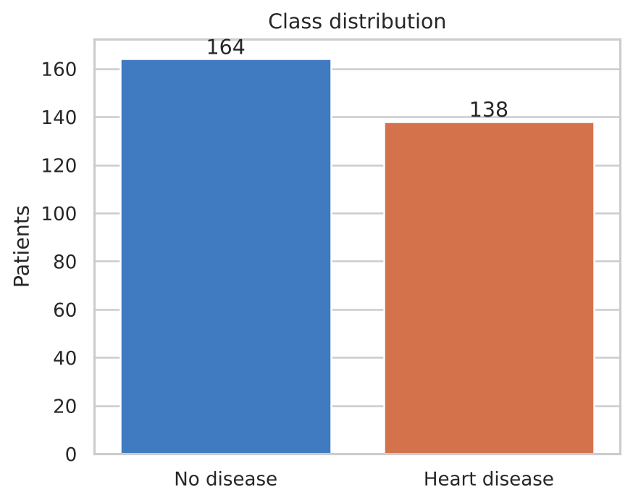
Figure 1. Class distribution generated by the supplied project.

5.2 Feature distributions and category rates
The project generates numeric-distribution plots and category-wise disease-rate charts. These allow the reader to compare variables such as age, resting blood pressure, cholesterol, maximum heart rate, and ST depression, and to inspect differences among coded clinical categories. Such patterns are descriptive associations in this small dataset and should not be interpreted as causal effects.
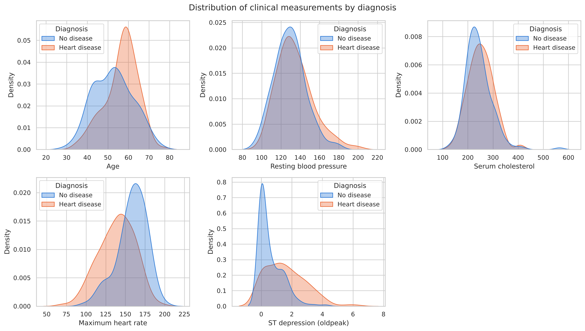
Figure 2. Numerical feature distributions.
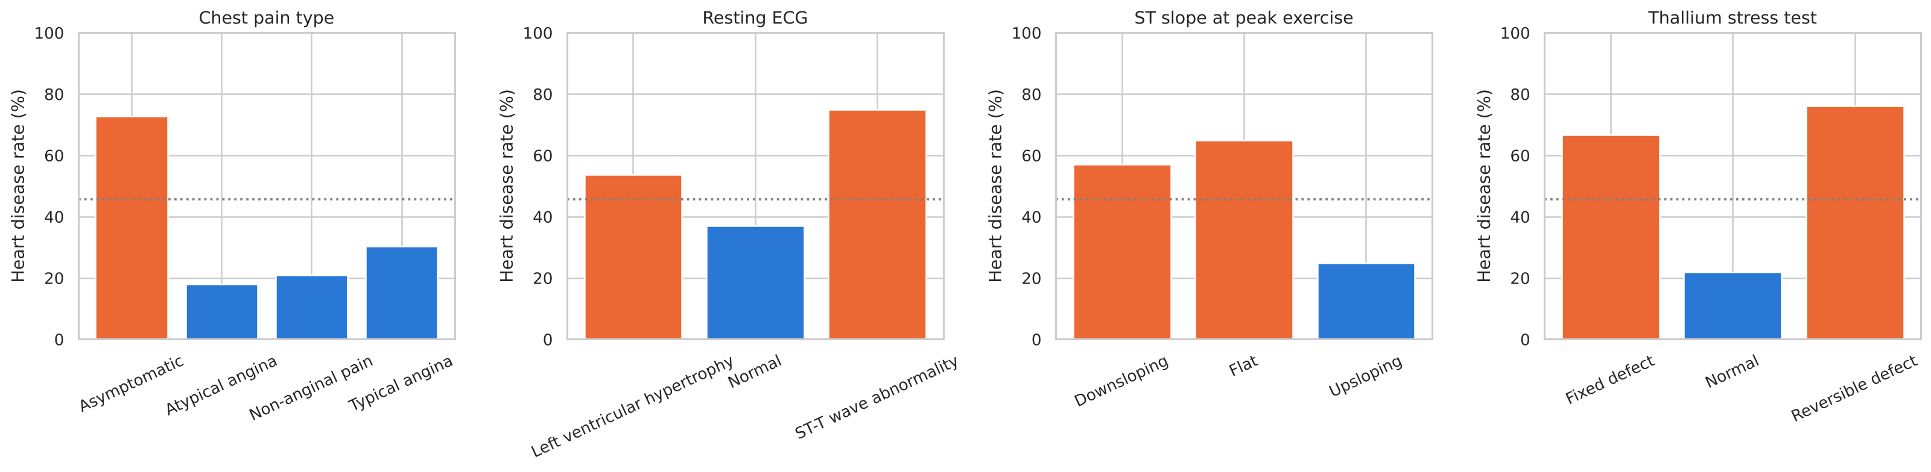
Figure 3. Disease rate across categorical feature values.

5.3 Correlation and feature relationships
The correlation heatmap summarizes pairwise linear associations, while the age-versus-maximum-heart-rate plot examines two measurements together. Correlation is useful for exploration but does not establish causation and may not capture non-linear relationships.
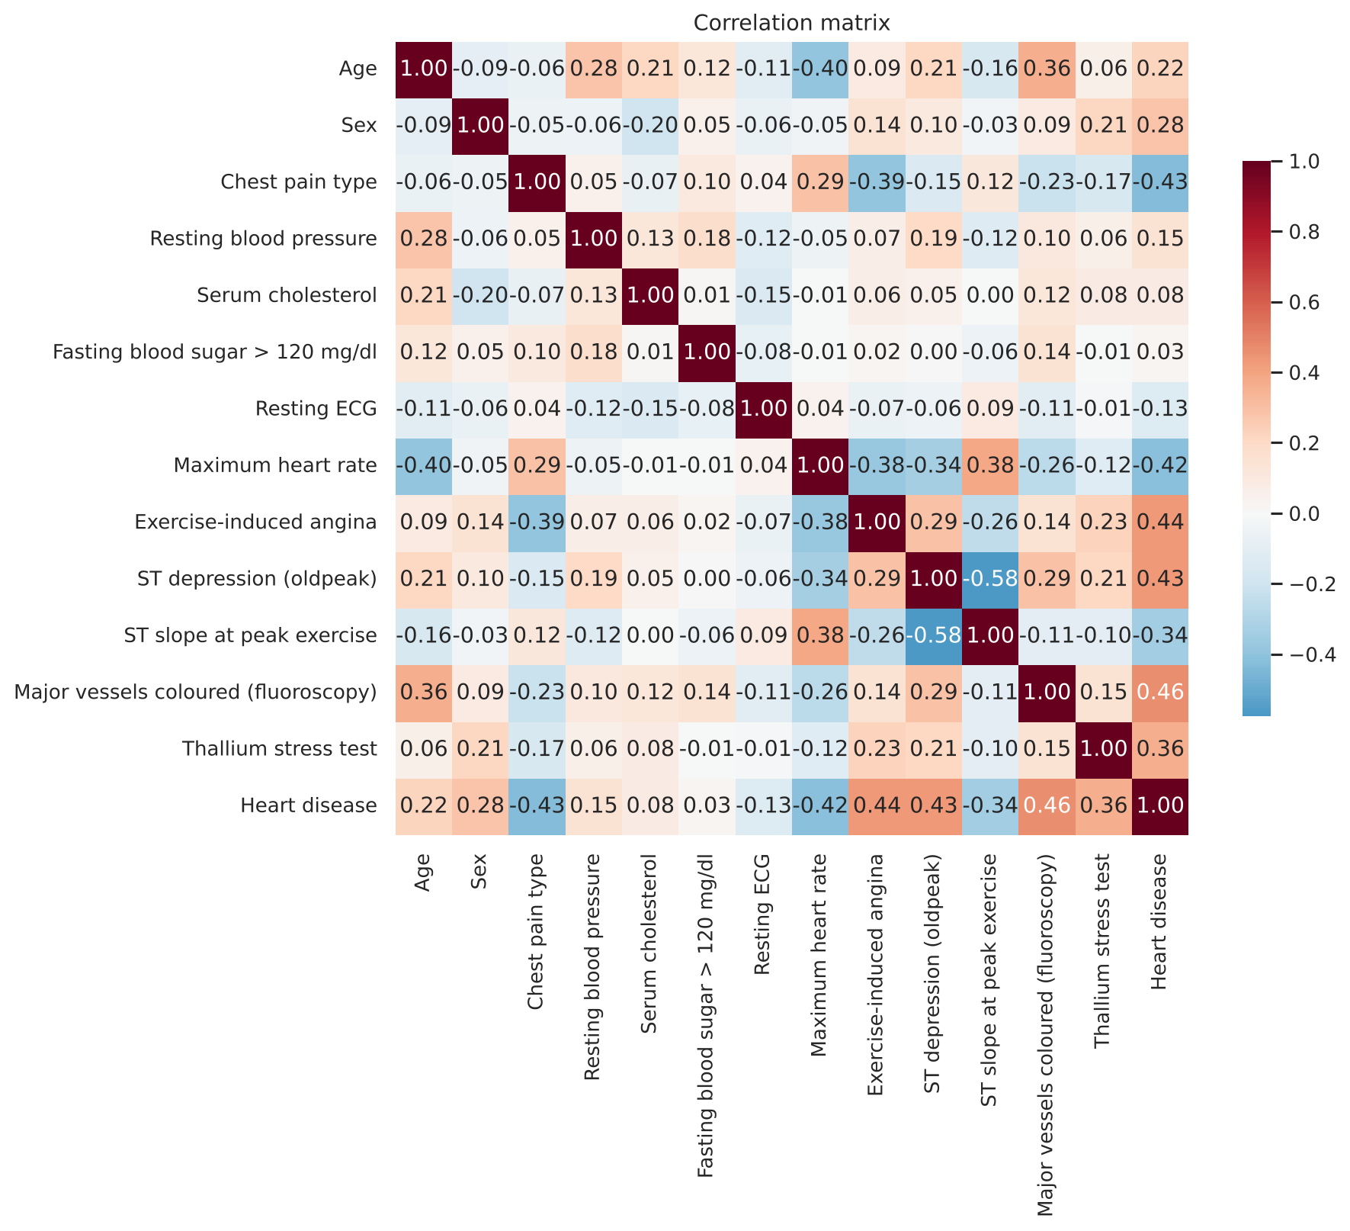
Figure 4. Feature correlation heatmap.
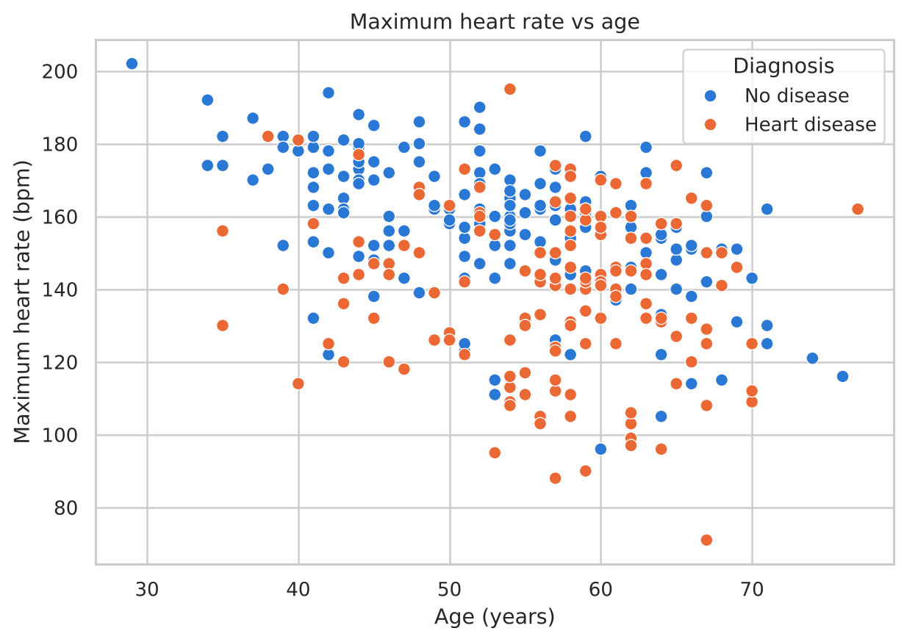
Figure 5. Age and maximum heart-rate relationship.

6. Data Preprocessing and Feature Engineering

6.1 Cleaning
The preprocessing module loads the CSV using UTF-8-with-BOM handling, trims column names, audits data quality, removes duplicate rows, converts the invalid ca and thal codes to missing values, and creates the corrected disease target. The explicit invalid-code handling is necessary because this CSV export encoded some originally missing values as numbers outside the allowed ranges.

6.2 Train/test split
The project uses a stratified 80/20 hold-out split with random_state = 42. The cleaned data is divided into 241 training records and 61 test records. Stratification preserves approximately the same class proportion in both subsets. The test set is held out for final evaluation.

6.3 Preprocessing pipeline
- Numeric features: median imputation followed by standard scaling.
- Ordinal feature ca: most-frequent imputation followed by scaling.
- Binary features: most-frequent imputation, retaining the 0/1 representation.
- Nominal features: most-frequent imputation followed by one-hot encoding.
These transformations are embedded inside each scikit-learn Pipeline. As a result, imputation values, scaling parameters, and category encoding are fitted within the training data for each fold rather than being calculated from the full dataset. This reduces leakage and helps ensure the same transformations are applied during training and prediction.

7. Model Development and Validation

7.1 Candidate classifiers
Model | Role in comparison
Logistic Regression | Linear probabilistic baseline; regularization is tuned.
K-Nearest Neighbours | Classifies using nearby examples in transformed feature space.
Support Vector Machine (RBF) | Kernel classifier capable of non-linear decision boundaries.
Gaussian Naive Bayes | Probabilistic classifier based on conditional-independence assumptions.
Decision Tree | Rule-based model with cost-complexity pruning.
Random Forest | Ensemble of decision trees.
Gradient Boosting | Sequential ensemble that improves on previous errors.
Soft-Voting Ensemble | Combines predicted probabilities from multiple classifiers.

7.2 Validation strategy
The supplied README and training code describe nested cross-validation: an inner five-fold GridSearchCV tunes model hyperparameters using ROC-AUC, while an outer five-fold cross-validation repeated three times estimates generalization performance. The held-out test set is evaluated separately. This design helps reduce the optimistic bias that can arise when the same folds are used both to choose hyperparameters and report performance.

7.3 Model selection and threshold
The project selects the model with the highest mean outer-fold ROC-AUC. The Support Vector Machine was selected with a mean ROC-AUC of about 0.912 and a standard deviation of about 0.041. The saved training report records SVM parameters C = 1 and gamma = 0.01. A classification threshold is selected from out-of-fold training probabilities using Youden's J statistic, rather than assuming that 0.50 is always the best threshold.

8. Results and Discussion

8.1 Nested cross-validation results
Model | Mean ROC-AUC ± SD | Accuracy | Precision | Recall | F1
Support Vector Machine | 0.912 ± 0.041 | 0.856 | 0.898 | 0.779 | 0.830
Logistic Regression | 0.910 ± 0.041 | 0.853 | 0.883 | 0.791 | 0.830
Naive Bayes | 0.909 ± 0.036 | 0.852 | 0.845 | 0.833 | 0.837
Soft-Voting Ensemble | 0.909 ± 0.039 | 0.842 | 0.853 | 0.803 | 0.823
Random Forest | 0.906 ± 0.044 | 0.831 | 0.836 | 0.791 | 0.809
Gradient Boosting | 0.900 ± 0.044 | 0.831 | 0.838 | 0.791 | 0.810
K-Nearest Neighbours | 0.891 ± 0.054 | 0.826 | 0.845 | 0.764 | 0.799
Decision Tree | 0.823 ± 0.063 | 0.768 | 0.774 | 0.700 | 0.731

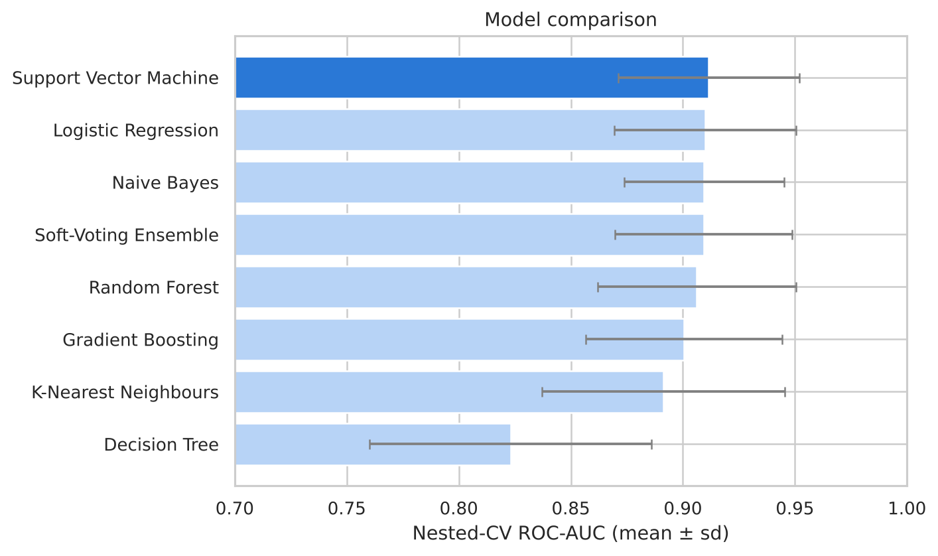
Figure 6. Model comparison figure generated by the project.

8.2 Held-out test results
Model | Accuracy | Precision | Recall | Specificity | F1-score | ROC-AUC
Support Vector Machine | 0.852 | 0.880 | 0.786 | 0.909 | 0.830 | 0.911
Logistic Regression | 0.852 | 0.880 | 0.786 | 0.909 | 0.830 | 0.920
Naive Bayes | 0.852 | 0.828 | 0.857 | 0.848 | 0.842 | 0.907
Soft-Voting Ensemble | 0.820 | 0.905 | 0.679 | 0.939 | 0.776 | 0.907
Random Forest | 0.803 | 0.864 | 0.679 | 0.909 | 0.760 | 0.889
Gradient Boosting | 0.820 | 0.840 | 0.750 | 0.879 | 0.792 | 0.908
K-Nearest Neighbours | 0.787 | 0.800 | 0.714 | 0.848 | 0.755 | 0.905
Decision Tree | 0.787 | 0.800 | 0.714 | 0.848 | 0.755 | 0.834

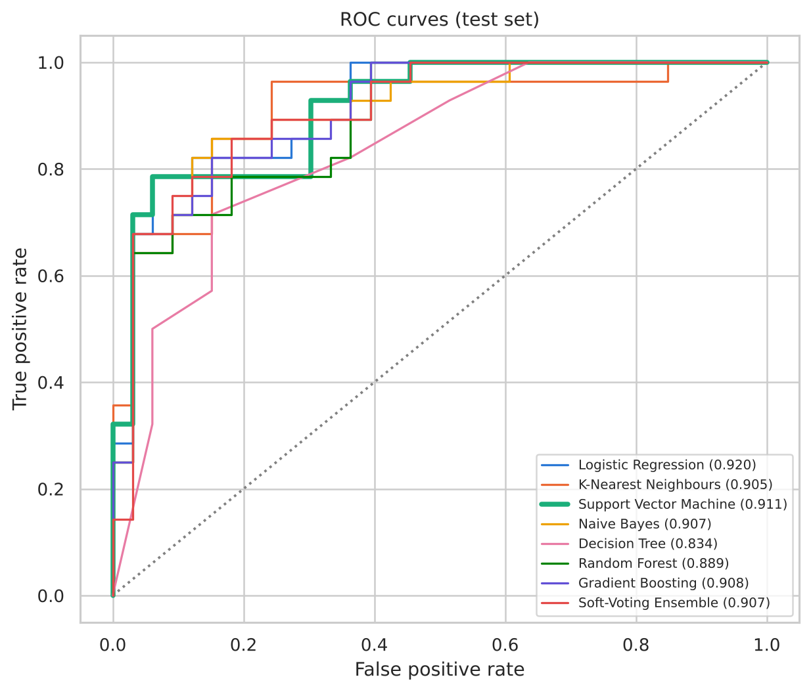
Figure 7. ROC curves for the candidate classifiers.
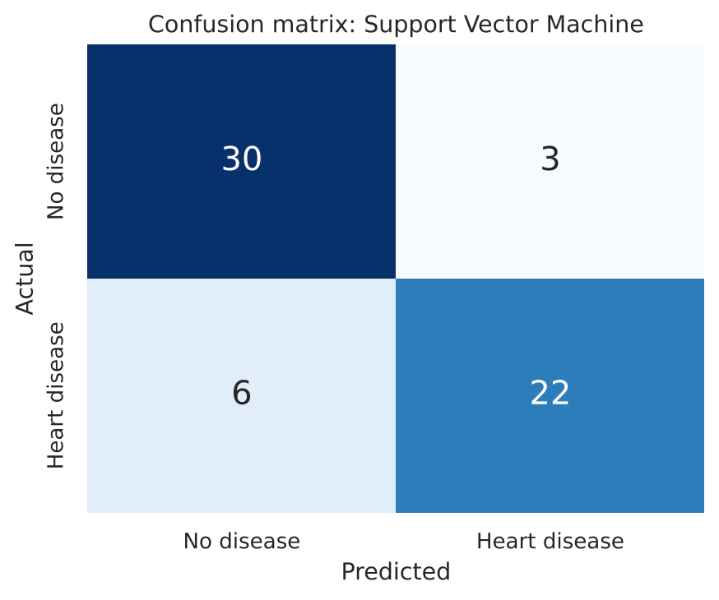
Figure 8. Confusion matrix for the selected model.

8.3 Interpretation
The selected Support Vector Machine achieved 85.2% test accuracy, 0.880 precision, 0.786 recall, 0.909 specificity, an F1-score of 0.830, and a test ROC-AUC of 0.911. Logistic Regression and Naive Bayes also performed competitively. The small dataset means small differences should not be treated as definitive evidence that one algorithm is universally superior.
Recall measures the fraction of actual disease-positive records identified by the model; specificity measures the fraction of no-disease records correctly identified. Precision indicates how many positive predictions are correct. These measures describe different error trade-offs, so no single score should be considered sufficient for a healthcare-related classifier.

8.4 Feature importance and explainability
Feature code | Permutation importance (mean score change)
ca | 0.0832
cp | 0.0312
oldpeak | 0.0125
thalach | 0.0124
thal | 0.0069
exang | 0.0029

Permutation importance is calculated by measuring how model performance changes when one feature is permuted. In the supplied report, ca (number of major vessels), cp (chest pain type), oldpeak, thalach, and thal appear among the strongest positive importance values. Small or negative estimates can occur when a feature contributes little on this particular split or when features contain overlapping information. Importance is model- and dataset-dependent, not a causal explanation.
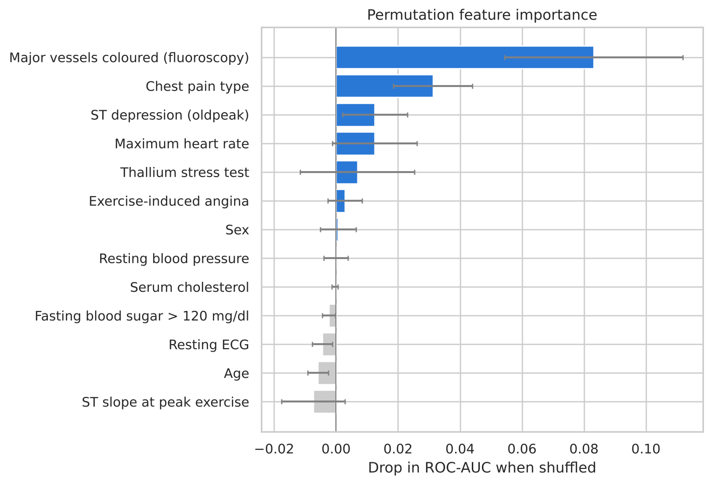
Figure 9. Permutation feature importance.
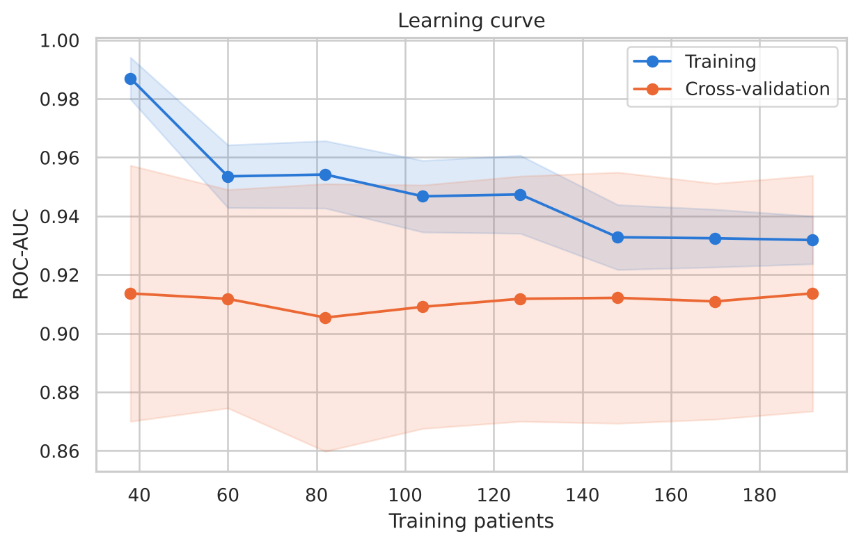
Figure 10. Learning curve diagnostic.

9. Application Features and Deployment

9.1 Streamlit application
Page | Purpose
Overview | Displays headline dataset and model results and summarizes the workflow.
Data Explorer | Shows the data-quality audit, feature distributions, relationships, insights, and raw data.
Model Lab | Presents model metrics, ROC and precision-recall views, confusion matrix, threshold controls, permutation importance, learning curve, and calibration.
Patient Segments | Explores K-means clusters with silhouette analysis, PCA visualization, and segment profiles.
Risk Predictor | Accepts one patient's clinical attributes and shows the predicted class, probability, and explanation.
Batch Prediction | Accepts a CSV for multiple predictions and allows the results to be downloaded.
About | Explains the methodology and limitations.

9.2 Command-line and REST API
The project includes a command-line prediction module and a FastAPI application. The API exposes a health endpoint and a prediction endpoint; optional explanation output can include feature contribution information.

9.3 Running the application
From the heart_disease_prediction project directory, install the dependencies:
pip install -r requirements.txt
Launch the Streamlit interface:
streamlit run app.py
Optional commands documented in the README:
- python src/train.py
- python src/report_figures.py
- python src/predict.py
- uvicorn src.api:app --reload
The trained model is already supplied in model/, so retraining is optional unless the dataset or implementation is changed.

10. Limitations and Responsible Use
- The cleaned dataset has only 302 patient records and originates from one historical source; performance may not generalize to other populations or clinical settings.
- The evaluation uses one held-out train/test split alongside repeated nested cross-validation. More external validation would be required before considering real-world use.
- The target-label correction is based on observed clinical-direction evidence in this CSV export. The mapping should be checked against the original dataset documentation before clinical interpretation.
- Some invalid category codes are treated as hidden missing values. This is a reasonable repair for this export, but source-data provenance should be documented.
- Predicted probabilities are model estimates and may not be calibrated for other populations or decision contexts.
- The application is an educational software project, not a certified medical device. It must not be used to diagnose, rule out, or treat heart disease.
Anyone with symptoms or concerns about heart health should seek advice from a qualified healthcare professional. A machine-learning score should not delay emergency care or replace professional assessment.

11. Conclusion and Future Work
The supplied project implements a broad machine-learning workflow for preliminary heart-disease risk estimation. It goes beyond a basic classifier by including a data audit, correction of a likely reversed target label, fold-safe preprocessing, nested cross-validation, several evaluation metrics, explainability, patient segmentation, and multiple ways to access predictions.
Support Vector Machine (RBF) was selected because it achieved the highest mean outer-fold ROC-AUC (approximately 0.912 ± 0.041). On the held-out test set it achieved approximately 85.2% accuracy and 0.911 ROC-AUC. These results demonstrate the workflow on a benchmark dataset, but do not establish clinical readiness.

11.1 Future work
- Validate the corrected target and category mapping against the original UCI source documentation.
- Evaluate the pipeline on larger and more diverse external datasets.
- Repeat evaluation with additional data splits and report uncertainty intervals.
- Improve probability calibration and study the practical effects of different decision thresholds.
- Collect structured user feedback on the interface while keeping the project in an educational setting.
- Expand explanation methods and assess the stability of feature importance across resamples.

References
Detrano, R. et al. (1989). Cleveland Heart Disease dataset, UCI Machine Learning Repository.
Scikit-learn documentation. Model selection, preprocessing pipelines, classification metrics, and clustering.
Streamlit documentation. Building interactive Python data applications.
FastAPI documentation. Building APIs with Python type hints.
Project source files supplied in qwertyuiop(1).zip: README.md; src/config.py; src/preprocess.py; src/train.py; src/predict.py; src/api.py; app.py; model/training_report.json.

